**Example websites:**

lovebylara.com.au/weddings/our-journey/

<https://shannonoheir.com.au/>

<https://www.aislemeetsannie.com/>

https://www.meganknoxcelebrancy.com/home/#services

**Overall design**

* I would like the website to be simple with some accents of colour
* PLEASE MAKE FONTS CONSISTENT, EXAMPLE (But please choose good font from website developer – no good fonts on word).

HEADINGS

Subheadings

Body

**Layout**

[LOGO – Centre middle of page above menu options]

|  |  |  |  |
| --- | --- | --- | --- |
| Home | About me | Packages | Contact |

1. **Home page:**
   1. Picture of me and ‘about me’ as follows:

Hey there, I’m Haya!

A young, fun, authentic marriage celebrant based in Canberra. In my not-so-spare time, I am a lawyer and owner of half-finished craft projects.

My favourite part of every wedding is the ceremony. Witnessing couples as they share their stories of how they met, laugh about their inside jokes, and talk about their future hopes and dreams is so special and sacred. As a celebrant, being able to share these moments with couples on their wedding day is an absolute honour.

If you can’t already tell, I will absolutely love getting to know every detail of your love journey – over coffee, wine, video-call, you name it! I strongly believe that your ceremony should be uniquely YOU, and so I’ll use this information to create a personalised wedding ceremony, interwoven with any readings, poems or rituals suited to you and your vision.

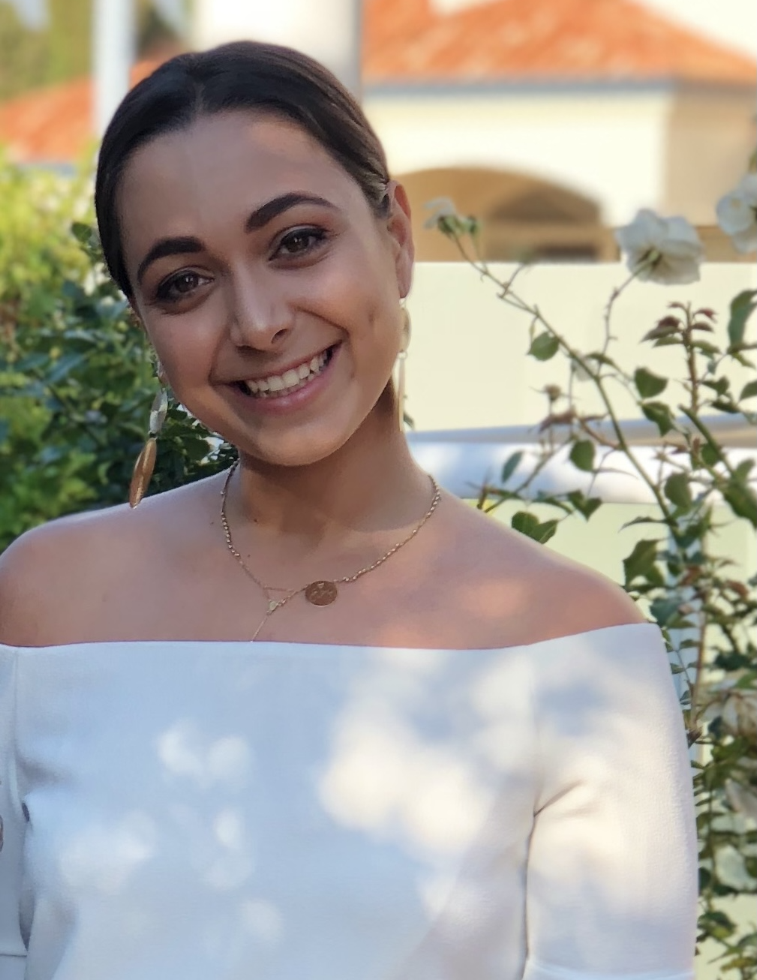

1. **packages**

|  |  |  |
| --- | --- | --- |
| Package title | Description | Price |
| No frills, just you, me and my skills | Let’s get this show on the road, quick and easy! This package is for couples wanting to get all the legal-work done, no fuss. Maybe you’re heading overseas & wanna take your main squeeze, or maybe you wanna save the dosh and splash out on a big honeymoon – whatever your deal is, this may be the package for you.   * Intimate ceremony, including yourselves and your two witnesses. * One face-to-face meeting to get all the paperwork sorted and have a quick chat about your plans. * Unlimited contact – seriously, call or text me whenever. * A short 5 minute ceremony including an introduction, my legal words, your legal words, and signing all the paperwork. * Lodgment of all legal paperwork * No rehearsal * No PA   Not available on Saturdays. | $550 |
| The sidekick | So, your bestie loves a mic and an audience, but they’re not quite qualified to make your marriage legit – I’ll be their sidekick!   * Access to my Getting Married resources including all you need to know about ceremony structures, and examples of rituals and readings. * Unlimited contact – seriously, call or text me whenever. * One face-to-face meeting with just you. * One face-to-face meeting with you and the friend who will be conducting the non-legal components of the ceremony. * Feedback on one draft * Use of my PA system * Me conducting all the legal components of the ceremony, signing and witnessing your paperwork. * Lodgment of legal documents. * No rehearsal*   *Rehearsal may be added for an additional fee. | $800 |
| The Lot! | **[description TBC]**   * Unlimited number of guests * Ceremony written from scratch, 100% personalised to you, with an unlimited number of revisions until you are absolutely happy! * Access to my Getting Married resources including all you need to know about ceremony structures, and examples of rituals and readings. * Unlimited contact – seriously, call or text me whenever. * Use of my PA system * Two face-to-face meetings * Rehearsal (optional) | $1,100 |

**3. Contact page**

* Contact page including details below.
* enquiry linked to [marriedbyhaya@gmail.com](mailto:marriedbyhaya@gmail.com) (I want to receive an email of the enquiry once it’s made)
  + Can you also make it so that the person who enquiries receives an automated confirmation of enquiry?

